 Addis Ababa Science And Technology University
Collage of Electrical And Mechanical Enginering
Department of software Engineering
Internet Programming
Group Assignment Section B
Personalized Virtual DigitalManagment System
Team Members ID
Gelila Melaku----------------------------------------------------ETS0618/16
Haleluya Gashawtena-------------------------------------------ETS0646/16
Halwa Mohammed----------------------------------------------ETS 0647/16
Hana Gadissa-----------------------------------------------------ETS 0653/16
Haven Goitom----------------------------------------------------ETS0667/16
Hiwot Anmut-----------------------------------------------------ETS0721/16
Submitted To: Mr.Jersualem
Submitted Date: 19 January 2026
Table of contents

1. Introduction 1
2. Context 1
2.2. Background Information 1
2.3. Operating Environment 1
3. Motivation 1
4. Objective 2
4.1. General Objective 2
4.2. Specific Objectives 2
5. Corresponding Requirements 2
6. Functional Requirements 3
7. Significance of The System 3
8. Beneficiaries of The System 3
9. Feasibility Analysis 3
9.1. Technical Feasibility 3
9.2. Economic Feasibility 4
9.3. Operational Feasibility 4
10. SRS Overview of The Existing System 4
10.1. Use Case of Existing System 4
10.2. Problems and Limitations 4
11. Proposed System 4
11.1. Use Case of Proposed System 4
11.2. Improvements Over Existing System 5
12. Featured Products (Adaptive Features) 5
13. Demonstration 6
14. Conclusion 10
15. References 11

Introduction
The Personalized Virtual Library Management System (PVLMS) is designed to automate and simplify the management of digital book collections. The system enables users to store, organize, search, and manage book information through an interactive and user-friendly platform. By digitizing the library management process, the system reduces manual workload and improves data accuracy and accessibility.

Context

2.2. Background Information
The system is intended for use in educational institutions, small community libraries, and individual users who need an efficient way to manage book records digitally. Many students and small libraries still rely on paper-based records or basic tools such as notebooks and spreadsheets, which are inefficient and error-prone.
With the advancement of web technologies, browser-based information systems have become a practical solution for small-scale management problems. The proposed system operates in a web environment and does not require expensive hardware or server infrastructure. It runs locally on the user’s browser, making it accessible, affordable, and easy to maintain.

2.3. Operating Environment
- Web browsers supporting HTML5, CSS3, and JavaScript
- Desktop or laptop computers
- Offline capability after initial loading
- Local storage (browser-based data persistence)

Motivation
The motivation for choosing this project arises from the challenges observed in managing personal and small institutional book collections. Existing systems are either manual or overly complex, requiring technical expertise and costly infrastructure.
Key motivating factors include:
- Difficulty in organizing and tracking books manually
- Lack of personalized features in traditional systems
- Time-consuming search and retrieval processes
- Risk of data loss and inconsistency
This project aims to provide a simple, cost-effective, and personalized solution that addresses these issues while also serving as a practical learning experience in system analysis, modeling, and implementation.

Objective

4.1. General Objective
To design and develop a Personalized Virtual Library Management System that automates book management processes and provides a secure, efficient, and user-friendly platform for managing digital book collections.

4.2. Specific Objectives
- To allow users to add, edit, and delete book records
- To enable fast searching and filtering of books
- To provide personalized digital shelves for users
- To store book data securely using local storage
- To design a responsive and intuitive user interface
- To reduce errors associated with manual record keeping

Corresponding Requirements

Objective | Supporting Requirement
Automate book management | Book CRUD functionality
Improve accessibility | Search and filter features
Personalization | User login and personal shelves
Data security | Local storage data persistence
Ease of use | Responsive and intuitive UI
Reliability | Offline access capability

6. Functional Requirements
- The system shall allow users to register using a username and password
- The system shall allow users to log in securely
- The system shall allow users to add new books with metadata
- The system shall allow users to edit existing book records
- The system shall allow users to delete book records
- The system shall display books in a digital shelf layout
- The system shall allow searching by title, author, or genre
- The system shall store data using browser localStorage
- The system shall maintain user sessions
- The system shall allow users to log out

7. Significance of The System
The system provides an effective digital solution for managing books, reducing reliance on manual systems. It improves productivity, minimizes errors, and enhances user satisfaction. Additionally, it promotes digital literacy and supports modern information management practices.

8. Beneficiaries of The System
- Students managing personal study materials
- Small libraries and community centers
- Educational institutions
- Individuals seeking organized digital book storage
- Software engineering students (learning purpose)

9. Feasibility Analysis

9.1. Technical Feasibility
The system uses standard web technologies and requires no specialized hardware or backend server. Developers can easily implement and maintain it using modern browsers and development tools.

9.2. Economic Feasibility
The system is cost-effective as it requires no paid software or infrastructure. Development and maintenance costs are minimal, making it financially viable.

9.3. Operational Feasibility
The system is easy to use and does not require technical training. Users can quickly learn how to manage books using the intuitive interface.

10. SRS Overview of The Existing System

10.1. Use Case of Existing System
- Manual entry of book records
- Paper-based or spreadsheet-based storage
- Manual searching and updating

10.2. Problems and Limitations
- Data redundancy and inconsistency
- Poor accessibility
- Risk of data loss
- Time-consuming processes
- Lack of personalization

11. Proposed System

11.1. Use Case of Proposed System
- User registration and login
- Book management (add, edit, delete)
- Search and filtering
- Personalized digital shelves
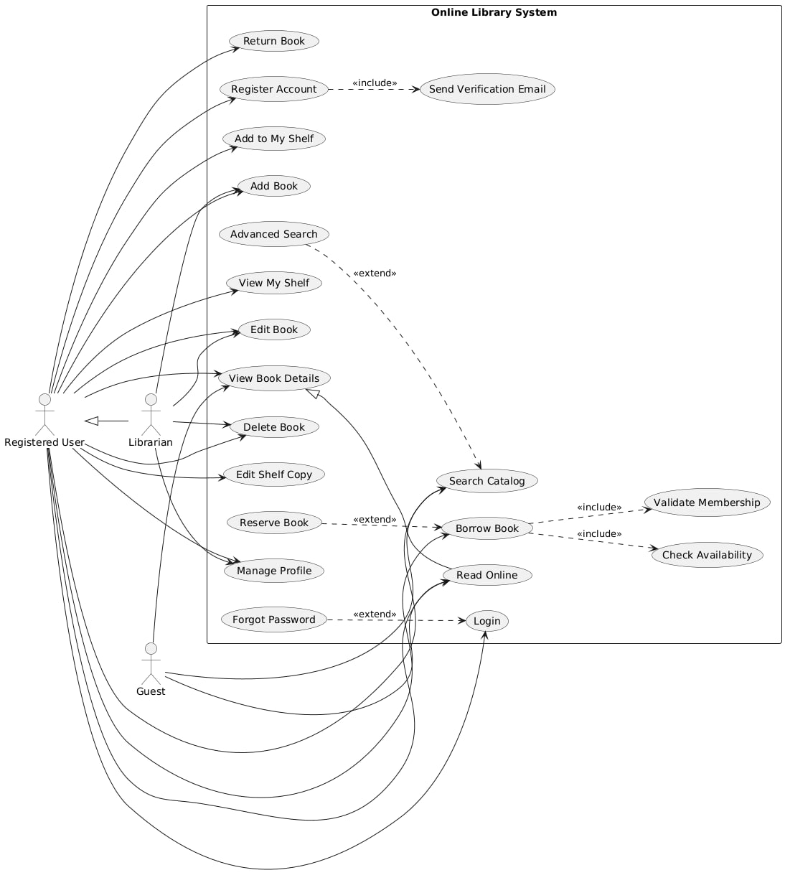

11.2. Improvements Over Existing System
- Automation of manual tasks
- Faster data retrieval
- Improved data security
- Personalized user experience
- Offline access capability

12. Featured Products (Adaptive Features)
The system adapts to user behavior by:
- Remembering frequently accessed books
- Organizing books based on usage patterns
- Providing personalized digital shelves
- Maintaining session preferences

13. Demonstration
This section is reserved for system demonstration, including: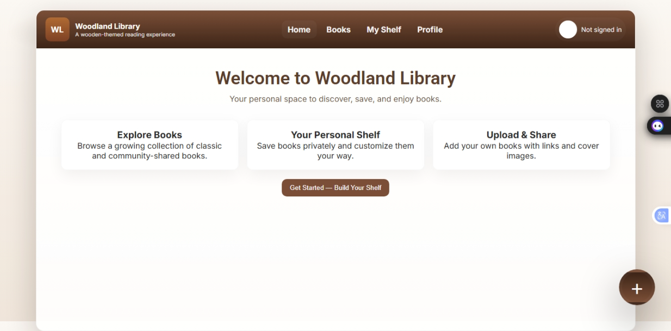
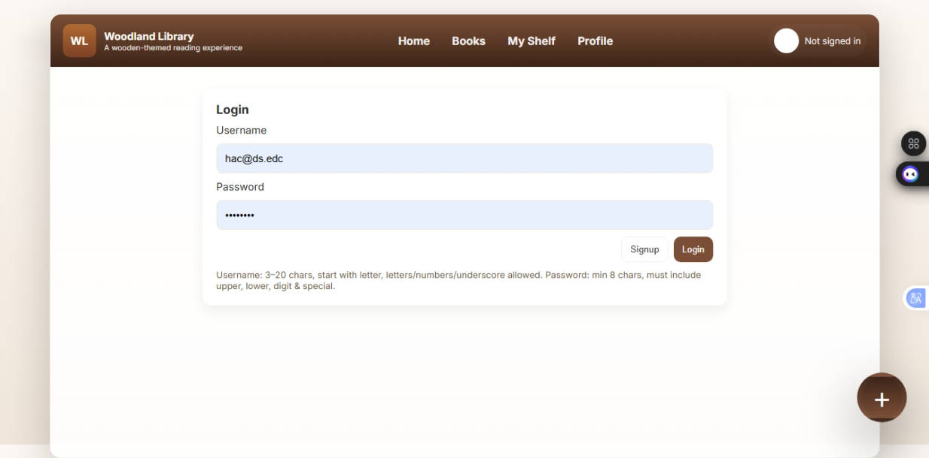
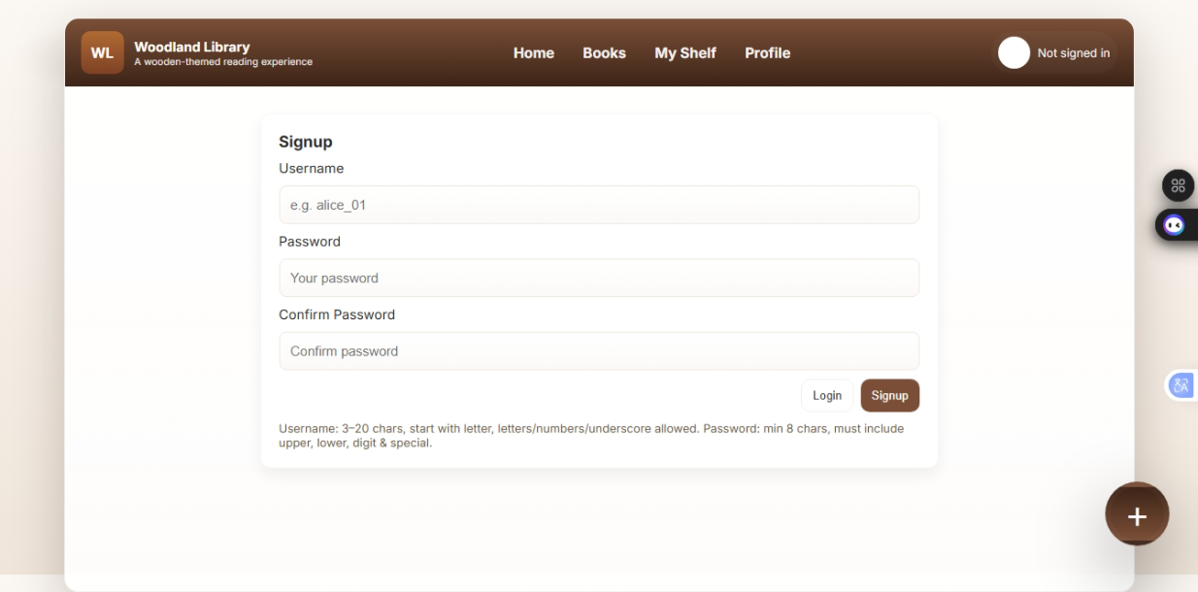

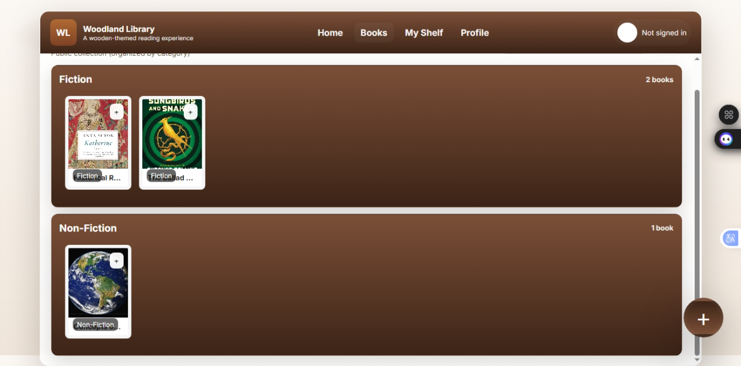
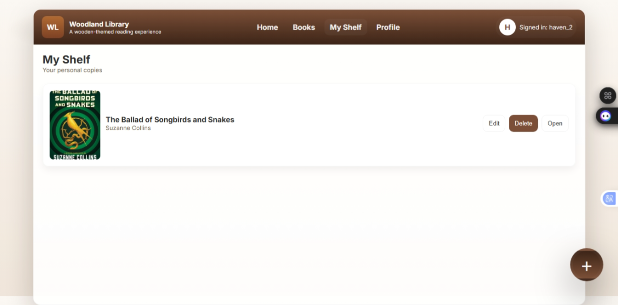
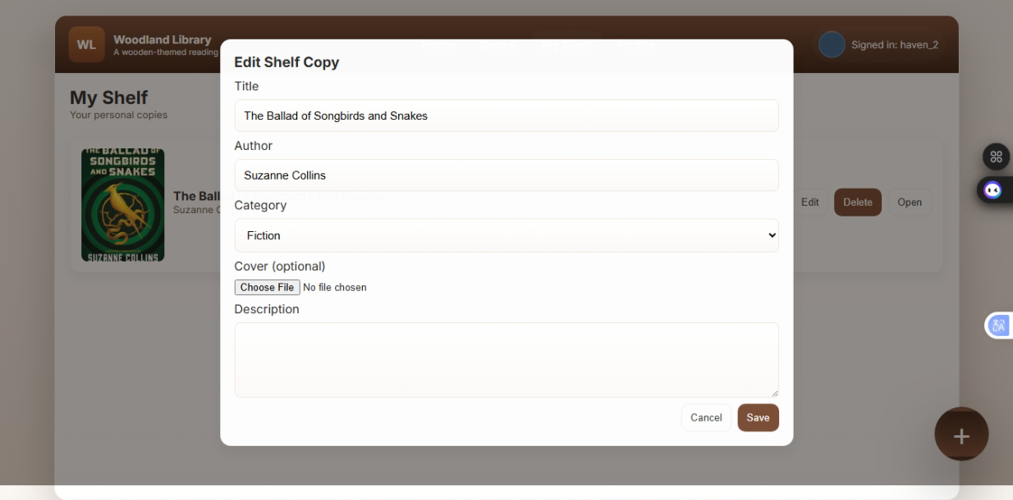
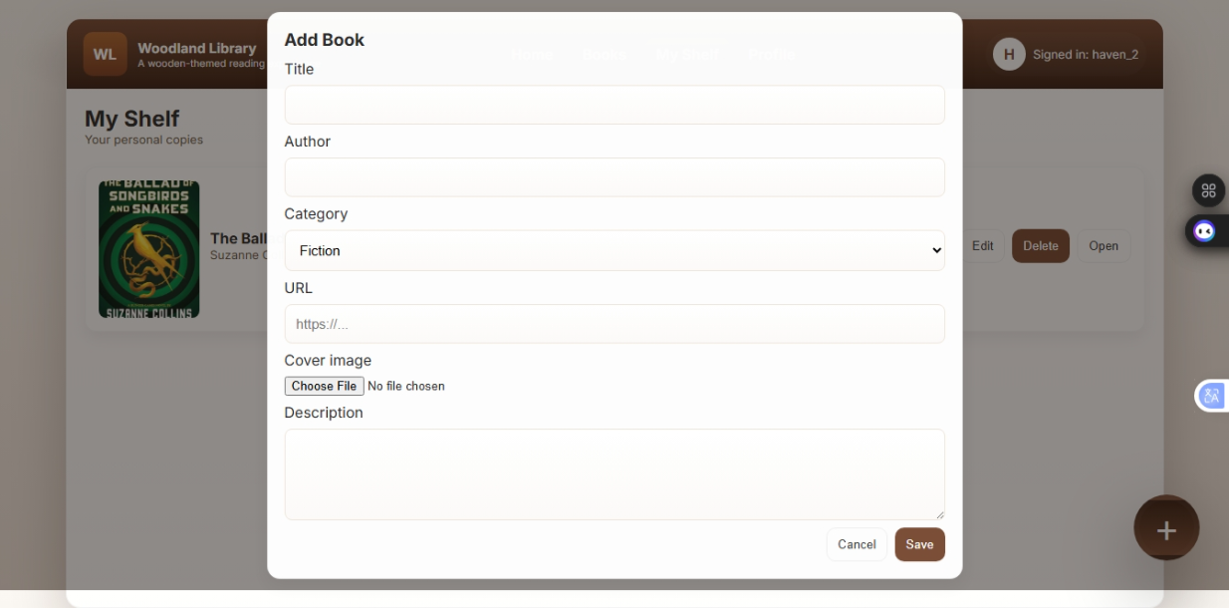
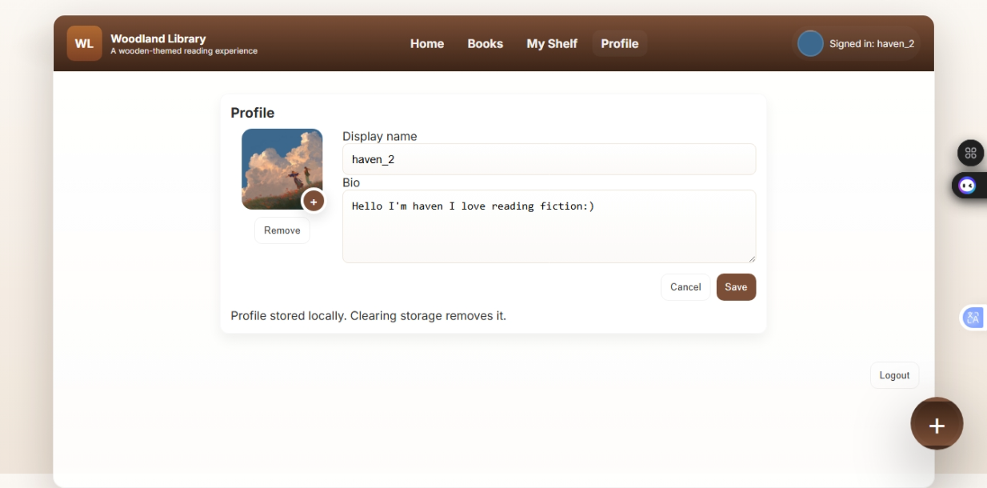

14. Conclusion
The Personalized Virtual Digital Management System successfully addresses the challenges associated with traditional and manual library management practices. By digitizing the process of storing, organizing, and retrieving book information, the system provides a practical, efficient, and user-friendly solution for individuals and small institutions. The implementation of browser-based technologies ensures ease of access, low operational cost, and minimal technical requirements, making the system highly adaptable to different user environments.
Through detailed requirement analysis and feasibility evaluation, the system was shown to be technically, economically, and operationally viable. The proposed system improves data accuracy, reduces redundancy, enhances accessibility, and supports personalized user interaction through individual digital shelves. Moreover, the system’s offline capability and local data storage increase reliability and usability, especially in environments with limited internet access.
Overall, the project demonstrates the effective application of system analysis and modeling principles in solving real-world problems. The Personalized Virtual Digital Management System not only fulfills its intended objectives but also provides a scalable foundation for future enhancements such as cloud integration, advanced recommendation mechanisms, and multi-user synchronization. This makes the system a valuable contribution to modern digital information management solutions.

15. References
Agile Alliance. (2022). What is agile? https://www.agilealliance.org/agile101/
Bashir, S., & Mahmood, A. (2020). Design and implementation of a web-based digital library system. International Journal of Advanced Computer Science and Applications, 11(2), 45–53. https://doi.org/10.14569/IJACSA.2020.0110206
Chowdhury, G. G. (2016). Introduction to modern information retrieval (4th ed.). Facet Publishing.
International Organization for Standardization. (2011). ISO/IEC 25010: Systems and software quality requirements and evaluation (SQuaRE) – System and software quality models. ISO.
Pressman, R. S., & Maxim, B. R. (2020). Software engineering: A practitioner’s approach (9th ed.). McGraw-Hill Education.

